RDFS Example:
<rdf:RDF
xmlns:rdf="http://www.w3.org/1999/02/22-rdf-syntax-ns#"
xmlns:rdfs="http://www.w3.org/2000/01/rdf-schema#">

<rdfs:Class rdf:ID="lecturer">
<rdfs:comment>
The class of lecturers.
All lecturers are academic staff members.
</rdfs:comment>
<rdfs:subClassOf rdf:resource="#academicStaffMember"/>
</rdfs:Class>
<rdfs:Class rdf:ID="academicStaffMember">
<rdfs:comment>
The class of academic staff members
</rdfs:comment>
<rdfs:subClassOf rdf:resource="#staffMember"/>
</rdfs:Class>

<rdfs:Class rdf:ID="staffMember">
<rdfs:comment>
The class of staff members
</rdfs:comment>
</rdfs:Class>

<rdfs:Class rdf:ID="course">
<rdfs:comment>
The class of courses
</rdfs:comment>
</rdfs:Class>

<rdf:Property rdf:ID="involves">
<rdfs:comment>
It relates only courses to lecturers
</rdfs:comment>
<rdfs:domain rdf:resource="#course"/>
<rdfs:range rdf:resource="#lecturer"/>
</rdf:Property>

<rdf:Property rdf:ID="isTaughtBy">
<rdfs:comment>
Inherits its domain ("course") and range ("lecturer")
from its superproperty "involves"
</rdfs:comment>
<rdfs:subPropertyOf rdf:resource="#involves"/>
</rdf:Property>

<rdf:Property rdf:ID="phone">
<rdfs:comment>
It is a property of staff members,
and takes literals as values.
</rdfs:comment>
<rdfs:domain rdf:resource="#staffMember"/>
<rdfs:range rdf:resource="http://www.w3.org/2000/01/rdf-schema#Literal"/>
</rdf:Property>-
DCMI Properties
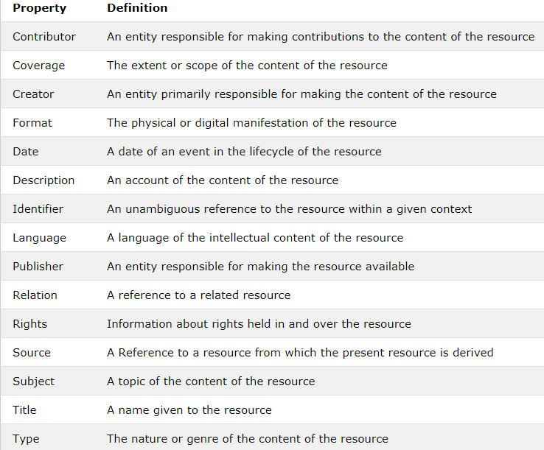
RDF Tags with DC (Dublin Core)
<?xml version="1.0"?>
<rdf:RDF
xmlns:rdf="http://www.w3.org/1999/02/22-rdf-syntax-ns#"
xmlns:dc= "http://purl.org/dc/elements/1.1/">
<rdf:Description rdf:about="https://www.w3schools.com">
<dc:description>W3Schools - Free tutorials</dc:description>
<dc:publisher>Refsnes Data as</dc:publisher>
<dc:date>2008-09-01</dc:date>
<dc:type>Web Development</dc:type>
<dc:format>text/html</dc:format>
<dc:language>en</dc:language>
</rdf:Description>
</rdf:RDF>
RDF/RDFS Classes
https://www.w3schools.com/xml/xml_rdf.asp
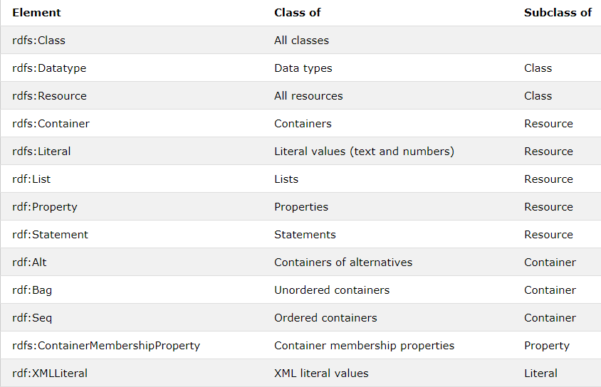

<?xml version="1.0"?>
<rdf:RDF
xmlns:rdf="http://www.w3.org/1999/02/22-rdf-syntax-ns#"
xmlns:rdfs="http://www.w3.org/2000/01/rdf-schema#"
xml:base="http://www.animals.fake/animals#">
<rdfs:Class rdf:ID="animal" />
<rdfs:Class rdf:ID="horse">
<rdfs:subClassOf rdf:resource="#animal"/>
</rdfs:Class>
</rdf:RDF>

RDFS/RDF Properties 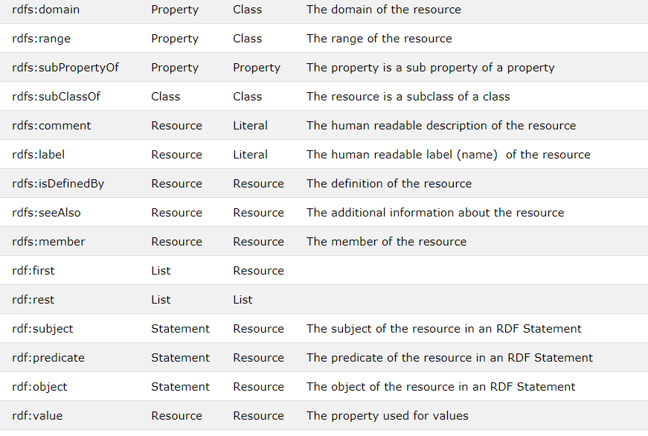
RDF Attributes
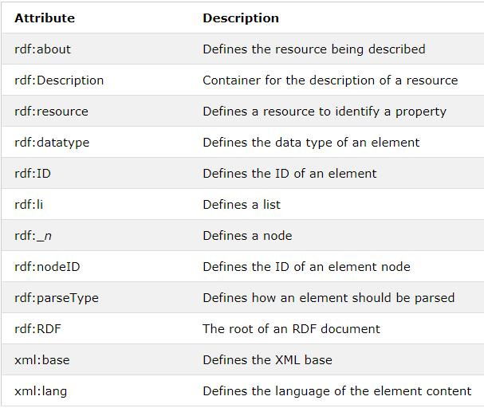

Example:
The model for the sentence
The students in course 6.001 are Amy, Tim, John, Mary, and Sue.
is written in RDF/XML as
<rdf:RDF>
<rdf:Description about="http://mycollege.edu/courses/6.001">
<s:students>
<rdf:Bag>
<rdf:li resource="http://mycollege.edu/students/Amy"/>
<rdf:li resource="http://mycollege.edu/students/Tim"/>
<rdf:li resource="http://mycollege.edu/students/John"/>
<rdf:li resource="http://mycollege.edu/students/Mary"/>
<rdf:li resource="http://mycollege.edu/students/Sue"/>
</rdf:Bag>
</s:students>
</rdf:Description>
</rdf:RDF>

Example:
Container = Bag
<rdf:Bag ID="pages">
<rdf:li resource="http://foo.org/foo.html" />
<rdf:li resource="http://bar.org/bar.html" />
</rdf:Bag>

<rdf:Description about="#pages">
<s:Creator>Ora Lassila</s:Creator>
</rdf:Description>

Example:
<rdf:RDF
xmlns:rdf="http://www.w3.org/1999/02/22-rdf-syntax-ns#"
xmlns:dc="http://purl.org/metadata/dublin_core#">

<rdf:Description about="http://www.foo.com/cool.html">
<dc:Creator>
<rdf:Seq ID="CreatorsAlphabeticalBySurname">
<rdf:li>Mary Andrew</rdf:li>
<rdf:li>Jacky Crystal</rdf:li>
</rdf:Seq>
</dc:Creator>

<dc:Identifier>
<rdf:Bag ID="MirroredSites">
<rdf:li rdf:resource="http://www.foo.com.au/cool.html"/>
<rdf:li rdf:resource="http://www.foo.com.it/cool.html"/>
</rdf:Bag>
</dc:Identifier>

<dc:Title>
<rdf:Alt>
<rdf:li xml:lang="en">The Coolest Web Page</rdf:li>
<rdf:li xml:lang="it">Il Pagio di Web Fuba</rdf:li>
</rdf:Alt>
</dc:Title>
</rdf:Description>
</rdf:RDF>
This example illustrates the use of all three types of collection. The order of the creators is deemed significant so the Sequence container is used to hold them. The locations on the Web are equivalent; order is not significant, therefore a Bag is used. The document has only a single title and that title has two variants, so the Alternatives container is used.
Example:
Dublin Core Metadata:

<rdf:RDF
xmlns:rdf="http://www.w3.org/1999/02/22-rdf-syntax-ns#"
xmlns:dc="http://purl.org/metadata/dublin_core#">

<rdf:Description about="http://www.dlib.org">
<dc:Title>D-Lib Program - Research in Digital Libraries</dc:Title>
<dc:Description>The D-Lib program supports the community of people
with research interests in digital libraries and electronic
publishing.</dc:Description>
<dc:Publisher>Corporation For National Research Initiatives </dc:Publisher>
<dc:Date>1995-01-07</dc:Date>
<dc:Subject>
<rdf:Bag>
<rdf:li>Research; statistical methods</rdf:li>
<rdf:li>Education, research, related topics</rdf:li>
<rdf:li>Library use Studies</rdf:li>
</rdf:Bag>
</dc:Subject>
<dc:Type>World Wide Web Home Page</dc:Type>
<dc:Format>text/html</dc:Format>
<dc:Language>en</dc:Language>
</rdf:Description>
</rdf:RDF>

Example:
Dublin Core Metadata:

<rdf:RDF
xmlns:rdf="http://www.w3.org/1999/02/22-rdf-syntax-ns#"
xmlns:dc="http://purl.org/metadata/dublin_core#"
xmlns:dcq="http://purl.org/metadata/dublin_core_qualifiers#">

<rdf:Description about="http://www.dlib.org/dlib/may98/05contents.html">
<dc:Title>DLIB Magazine - The Magazine for Digital Library Research
- May 1998</dc:Title>
<dc:Description>D-LIB magazine is a monthly compilation of
contributed stories, commentary, and briefings.</dc:Description>
<dc:Contributor rdf:parseType="Resource">
<dcq:AgentType
rdf:resource=http://purl.org/metadata/dublin_core_qualifiers#Editor/>
<rdf:value>Amy Friedlander</rdf:value>
</dc:Contributor>
<dc:Publisher>Corporation for National Research Initiatives</dc:Publisher>
<dc:Date>1998-01-05</dc:Date>
<dc:Type>electronic journal</dc:Type>
<dc:Subject>
<rdf:Bag>
<rdf:li>library use studies</rdf:li>
<rdf:li>magazines and newspapers</rdf:li>
</rdf:Bag>
</dc:Subject>
<dc:Format>text/html</dc:Format>
<dc:Identifier>urn:issn:1082-9873</dc:Identifier>
<dc:Relation rdf:parseType="Resource">
<dcq:RelationType
rdf:resource="http://purl.org/metadata/dublin_core_qualifiers#IsPartOf"/>
<rdf:value resource="http://www.dlib.org"/>
</dc:Relation>
</rdf:Description>
</rdf:RDF>

Example:
Specific article in the magazine.
<rdf:RDF
xmlns:rdf="http://www.w3.org/1999/02/22-rdf-syntax-ns#"
xmlns:dc="http://purl.org/metadata/dublin_core#"
xmlns:dcq="http://purl.org/metadata/dublin_core_qualifiers#">

<rdf:Description about=
"http://www.dlib.org/dlib/may98/miller/05miller.html">
<dc:Title>An Introduction to the Resource Description Framework</dc:Title>
<dc:Creator>Eric J. Miller</dc:Creator>
<dc:Description>The Resource Description Framework (RDF) is an
infrastructure that enables the encoding, exchange and reuse of
structured metadata. rdf is an application of xml that imposes needed
structural constraints to provide unambiguous methods of expressing
semantics. rdf additionally provides a means for publishing both
human-readable and machine-processable vocabularies designed to
encourage the reuse and extension of metadata semantics among
disparate information communities. the structural constraints rdf
imposes to support the consistent encoding and exchange of
standardized metadata provides for the interchangeability of separate
packages of metadata defined by different resource description
communities. </dc:Description>
<dc:Publisher>Corporation for National Research Initiatives</dc:Publisher>
<dc:Subject>
<rdf:Bag>
<rdf:li>machine-readable catalog record formats</rdf:li>
<rdf:li>applications of computer file organization and
access methods</rdf:li>
</rdf:Bag>
</dc:Subject>
<dc:Rights>Copyright @ 1998 Eric Miller</dc:Rights>
<dc:Type>Electronic Document</dc:Type>
<dc:Format>text/html</dc:Format>
<dc:Language>en</dc:Language>
<dc:Relation rdf:parseType="Resource">
<dcq:RelationType
rdf:resource="http://purl.org/metadata/dublin_core_qualifiers#IsPartOf"/>
<rdf:value resource="http://www.dlib.org/dlib/may98/05contents.html"/>
</dc:Relation>
</rdf:Description>
</rdf:RDF>

Example:
The RDF abbreviated syntax can frequently be used to write property values that are strings in XML attribute form
<rdf:RDF
xmlns:rdf="http://www.w3.org/1999/02/22-rdf-syntax-ns#"
xmlns:dc="http://purl.org/metadata/dublin_core#">
<rdf:Description about="http://www.foo.com/cool.html">
<dc:Creator>
<rdf:Seq ID="CreatorsAlphabeticalBySurname"
rdf:_1="Mary Andrew"
rdf:_2="Jacky Crystal"/>
</dc:Creator>
</rdf:Description>
</rdf:RDF>

RDFS-- Classes and Resources as Sets and Elements
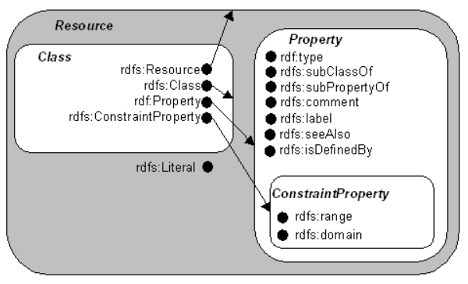
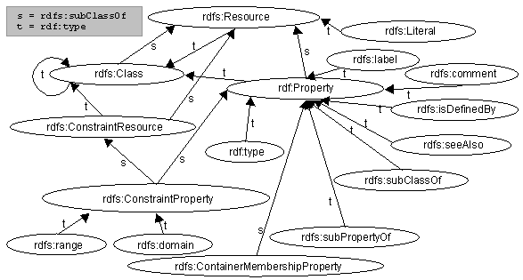
Example:
This is a very simple example that expresses the following class hierarchy. We first define a class 'MotorVehicle'. We then define 3 subclasses of 'MotorVehicle', namely 'PassengerVehicle', 'Truck' and 'Van'. We then define a class 'Minivan' which is a sub-class of both 'Van' and 'PassengerVehicle'.
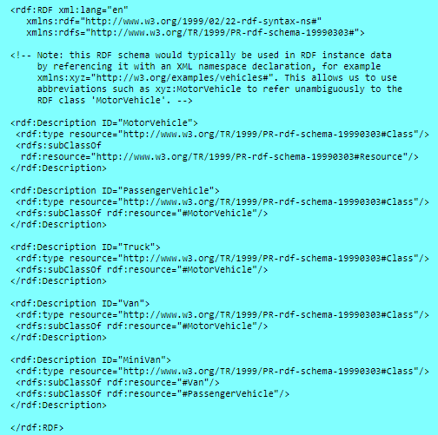

rdfs:subPropertyOf
Example
If the property biologicalFather is a sub-property of the broader property biologicalParent, and if Fred is the biologicalFather of John, then it is implied that Fred is also the biologicalParent of John.

Fred is BiologicalFather of John.
BiologicalFather isSubpropertyOf BiologicalParent.
So so so
Fred is BiologicalParent of John.
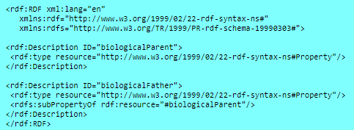

XML Serialization
The RDF specification of the above is given here in the serialization syntax. Please note that the namespace URIs listed are examples only; formal identifiers have not yet been assigned for these schemas. This schema includes annotations describing RDF resources defined formally in the RDF Model and Syntax specification, as well as definitions for new resources belonging to the RDF Schema namespace.
For example, the RDF below does not tell us that subClassOf arcs should not (to use terminology from the nodes and arcs representation) form loops in any RDF model.

Basic XML Serialization
<rdf:RDF
xmlns:rdf="http://www.w3.org/1999/02/22-rdf-syntax-ns#"
xmlns:rdfs="http://www.w3.org/TR/1999/PR-rdf-schema-19990303#">

<rdf:Description ID="Resource">
<rdf:type resource="#Class"/>
<rdfs:label xml:lang="en">Resource</rdfs:label>
<rdfs:label xml:lang="fr">Ressource</rdfs:label>
<rdfs:comment>The most general class</rdfs:comment>
</rdf:Description>

<rdf:Description about="http://www.w3.org/1999/02/22-rdf-syntax-ns#type">
<rdf:type resource="http://www.w3.org/1999/02/22-rdf-syntax-ns#Property"/>
<rdfs:label xml:lang="en">type</rdfs:label>
<rdfs:label xml:lang="fr">type</rdfs:label>
<rdfs:comment>Indicates membership of a class</rdfs:comment>
<rdfs:range rdf:resource="#Class"/>
</rdf:Description>

<rdf:Description ID="comment">
<rdf:type resource="http://www.w3.org/1999/02/22-rdf-syntax-ns#Property"/>
<rdfs:label xml:lang="en">comment</rdfs:label>
<rdfs:label xml:lang="fr">commentaire</rdfs:label>
<rdfs:domain rdf:resource="#Resource"/>
<rdfs:comment>Use this for descriptions</rdfs:comment>
<rdfs:range rdf:resource="http://www.w3.org/TR/1999/PR-rdf-schema-19990303#Literal"/>
</rdf:Description>

<rdf:Description ID="label">
<rdf:type resource="http://www.w3.org/1999/02/22-rdf-syntax-ns#Property"/>
<rdfs:label xml:lang="en">label</rdfs:label>
<rdfs:label xml:lang="fr">label</rdfs:label>
<rdfs:domain rdf:resource="#Resource"/>
<rdfs:comment>Provides a human-readable version of a resource name.</rdfs:comment>
<rdfs:range
rdf:resource="http://www.w3.org/TR/1999/PR-rdf-schema-19990303#Literal"/>
</rdf:Description>

<rdf:Description ID="Class">
<rdf:type resource="#Class"/>
<rdfs:label xml:lang="en">Class</rdfs:label>
<rdfs:label xml:lang="fr">Classe</rdfs:label>
<rdfs:comment>The concept of Class</rdfs:comment>
<rdfs:subClassOf rdf:resource="#Resource"/>
</rdf:Description>

<rdf:Description ID="subClassOf">
<rdf:type resource="http://www.w3.org/1999/02/22-rdf-syntax-ns#Property"/>
<rdfs:label xml:lang="en">subClassOf</rdfs:label>
<rdfs:label xml:lang="fr">sousClasseDe</rdfs:label>
<rdfs:comment>Indicates membership of a class</rdfs:comment>
<rdfs:range rdf:resource="#Class"/>
<rdfs:domain rdf:resource="#Class"/>
</rdf:Description>

<rdf:Description ID="subPropertyOf">
<rdf:type resource="http://www.w3.org/1999/02/22-rdf-syntax-ns#Property"/>
<rdfs:label xml:lang="en">subPropertyOf</rdfs:label>
<rdfs:label xml:lang="fr">sousPropriétéDe</rdfs:label>
<rdfs:comment>Indicates specialization of properties</rdfs:comment>
<rdfs:range rdf:resource="http://www.w3.org/1999/02/22-rdf-syntax-ns#Property"/>
<rdfs:domain rdf:resource="http://www.w3.org/1999/02/22-rdf-syntax-ns#Property"/>
</rdf:Description>

<rdf:Description ID="seeAlso">
<rdf:type resource="http://www.w3.org/1999/02/22-rdf-syntax-ns#Property"/>
<rdfs:label xml:lang="en">seeAlso</rdfs:label>
<rdfs:label xml:lang="fr">voirAussi</rdfs:label>
<rdfs:comment>Indicates a resource that provides information about the subject resource.</rdfs:comment>
<rdfs:range rdf:resource="http://www.w3.org/TR/1999/PR-rdf-schema-19990303#Resource"/>
<rdfs:domain rdf:resource="http://www.w3.org/TR/1999/PR-rdf-schema-19990303#Resource"/>
</rdf:Description>

<rdf:Description ID="isDefinedBy">
<rdf:type resource="http://www.w3.org/1999/02/22-rdf-syntax-ns#Property"/>
<rdfs:subPropertyOf rdf:resource="#seeAlso"/>
<rdfs:label xml:lang="en">isDefinedBy</rdfs:label>
<rdfs:label xml:lang="fr">esDéfiniPar</rdfs:label>
<rdfs:comment>Indicates a resource containing and defining the subject resource.</rdfs:comment>
<rdfs:range rdf:resource="http://www.w3.org/TR/1999/PR-rdf-schema-19990303#Resource"/>
<rdfs:domain rdf:resource="http://www.w3.org/TR/1999/PR-rdf-schema-19990303#Resource"/>
</rdf:Description>

<rdf:Description ID="ConstraintResource">
<rdfs:label xml:lang="en">ConstraintResource</rdfs:label>
<rdfs:label xml:lang="fr">RessourceContrainte</rdfs:label>
<rdf:type resource="#Class"/>
<rdfs:subClassOf rdf:resource="#Resource"/>
<rdfs:comment>Resources used to express RDF Schema constraints.</rdfs:comment>
</rdf:Description>

<rdf:Description ID="ConstraintProperty">
<rdfs:label xml:lang="en">ConstraintProperty</rdfs:label>
<rdfs:label xml:lang="fr">PropriétéContrainte</rdfs:label>
<rdf:type resource="#Class"/>
<rdfs:subClassOf rdf:resource="http://www.w3.org/1999/02/22-rdf-syntax-ns#Property"/>
<rdfs:subClassOf rdf:resource="#ConstraintResource"/>
<rdfs:comment>Properties used to express RDF Schema constraints.</rdfs:comment>
</rdf:Description>

<rdf:Description ID="domain">
<rdf:type resource="#ConstraintProperty"/>
<rdfs:label xml:lang="en">domain</rdfs:label>
<rdfs:label xml:lang="fr">domaine</rdfs:label>
<rdfs:comment>This is how we associate a class with
properties that its instances can have</rdfs:comment>
</rdf:Description>

<rdf:Description ID="range">
<rdf:type resource="#ConstraintProperty"/>
<rdfs:label xml:lang="en">range</rdfs:label>
<rdfs:label xml:lang="fr">étendue</rdfs:label>
<rdfs:comment>Properties that can be used in a
schema to provide constraints</rdfs:comment>
<rdfs:range rdf:resource="#Class"/>
<rdfs:domain rdf:resource="http://www.w3.org/1999/02/22-rdf-syntax-ns#Property"/>
</rdf:Description>

<rdf:Description ID="Property">
<rdfs:label xml:lang="en">Property</rdfs:label>
<rdfs:label xml:lang="fr">Propriété</rdfs:label>
<rdfs:comment>The concept of a property.</rdfs:comment>
<rdfs:subClassOf rdf:resource="#Resource"/>
<rdf:type resource="#Class"/>
</rdf:Description>

<rdf:Description ID="Literal">
<rdfs:label xml:lang="en">Literal</rdfs:label>
<rdfs:label xml:lang="fr">Littéral</rdfs:label>
<rdf:type resource="#Class"/>
<rdfs:comment>This represents the set of atomic values, eg. textual strings.</rdfs:comment>
</rdf:Description>

<rdf:Description about="http://www.w3.org/1999/02/22-rdf-syntax-ns#Statement">
<rdfs:label xml:lang="en">Statement</rdfs:label>
<rdfs:label xml:lang="fr">Déclaration</rdfs:label>
<rdf:type resource="#Class"/>
<rdfs:subClassOf rdf:resource="#Resource"/>
<rdfs:comment>This represents the set of reified statements.</rdfs:comment>
</rdf:Description>

<rdf:Description about="http://www.w3.org/1999/02/22-rdf-syntax-ns#subject">
<rdfs:label xml:lang="en">subject</rdfs:label>
<rdfs:label xml:lang="fr">sujet</rdfs:label>
<rdf:type resource="http://www.w3.org/1999/02/22-rdf-syntax-ns#Property"/>
<rdfs:domain rdf:resource="http://www.w3.org/1999/02/22-rdf-syntax-ns#Statement"/>
<rdfs:range rdf:resource="#Resource"/>
</rdf:Description>

<rdf:Description about="http://www.w3.org/1999/02/22-rdf-syntax-ns#predicate">
<rdfs:label xml:lang="en">predicate</rdfs:label>
<rdfs:label xml:lang="fr">prédicat</rdfs:label>
<rdf:type resource="http://www.w3.org/1999/02/22-rdf-syntax-ns#Property"/>
<rdfs:domain rdf:resource="http://www.w3.org/1999/02/22-rdf-syntax-ns#Statement"/>
<rdfs:range rdf:resource="http://www.w3.org/1999/02/22-rdf-syntax-ns#Property"/>
</rdf:Description>

<rdf:Description about="http://www.w3.org/1999/02/22-rdf-syntax-ns#object">
<rdfs:label xml:lang="en">object</rdfs:label>
<rdfs:label xml:lang="fr">objet</rdfs:label>
<rdf:type resource="http://www.w3.org/1999/02/22-rdf-syntax-ns#Property"/>
<rdfs:domain rdf:resource="http://www.w3.org/1999/02/22-rdf-syntax-ns#Statement"/>
</rdf:Description>

<rdf:Description ID="Container">
<rdfs:label xml:lang="en">Container</rdfs:label>
<rdfs:label xml:lang="fr">Enveloppe</rdfs:label>
<rdf:type resource="#Class"/>
<rdfs:subClassOf rdf:resource="#Resource"/>
<rdfs:comment>This represents the set Containers.</rdfs:comment>
</rdf:Description>

<rdf:Description about="http://www.w3.org/1999/02/22-rdf-syntax-ns#Bag">
<rdfs:label xml:lang="en">Bag</rdfs:label>
<rdfs:label xml:lang="fr">Ensemble</rdfs:label>
<rdf:type resource="#Class"/>
<rdfs:subClassOf rdf:resource="#Container"/>
</rdf:Description>

<rdf:Description about="http://www.w3.org/1999/02/22-rdf-syntax-ns#Seq">
<rdfs:label xml:lang="en">Sequence</rdfs:label>
<rdfs:label xml:lang="fr">Séquence</rdfs:label>
<rdf:type resource="#Class"/>
<rdfs:subClassOf rdf:resource="#Container"/>
</rdf:Description>

<rdf:Description about="http://www.w3.org/1999/02/22-rdf-syntax-ns#Alt">
<rdfs:label xml:lang="en">Alt</rdfs:label>
<rdfs:label xml:lang="fr">Choix</rdfs:label>
<rdf:type resource="#Class"/>
<rdfs:subClassOf rdf:resource="#Container"/>
</rdf:Description>

<rdf:Description ID="ContainerMembershipProperty">
<rdfs:label xml:lang="en">ContainerMembershipProperty</rdfs:label>
<rdf:type resource="#Class"/>
<rdfs:subClassOf rdf:resource="http://www.w3.org/1999/02/22-rdf-syntax-ns#Property"/>
</rdf:Description>

<rdf:Description about="http://www.w3.org/1999/02/22-rdf-syntax-ns#value">
<rdfs:label xml:lang="en">object</rdfs:label>
<rdfs:label xml:lang="fr">value</rdfs:label>
<rdf:type resource="http://www.w3.org/1999/02/22-rdf-syntax-ns#Property"/>
</rdf:Description>

</rdf:RDF>

Compact XML Serialization
The following is the same RDF data expressed using the more compact XML serialisation syntax. This representation is suitable for embedding in XML documents (such as this specification) intended for display, since the literal string values are encoded as the values of XML attributes, and as such are not displayed by HTML-oriented applications. The source code for this specification contains another copy of the following XML/RDF, making the document both human and machine readable.
<rdf:RDF xml:lang="en"
xmlns:rdf="http://www.w3.org/1999/02/22-rdf-syntax-ns#"
xmlns:rdfs="http://www.w3.org/TR/1999/PR-rdf-schema-19990303#">

<rdfs:Class rdf:ID="Resource"
rdfs:label="Resource"
rdfs:comment="The most general class/">

<rdf:Property about="http://www.w3.org/1999/02/22-rdf-syntax-ns#type"
rdfs:label="type"
rdfs:comment="Indicates membership of a class">
<rdfs:range rdf:resource="#Class"/>
</rdf:Property>

<rdf:Property ID="comment"
rdfs:comment="Use this for descriptions"
rdfs:label="comment">
<rdfs:domain rdf:resource="#Resource"/>
<rdfs:range rdf:resource="#Literal"/>
</rdf:Property>

<rdf:Property ID="label"
rdfs:Label="label"
rdfs:comment="Provides a human-readable version of a resource name">
<rdfs:domain rdf:resource="#Resource"/>
<rdfs:range rdf:resource="#Literal"/>
</rdf:Property>

<rdfs:Class rdf:ID="Class"
rdfs:label="Class"
rdfs:comment="The concept of Class">
<rdfs:subClassOf rdf:resource="#Resource"/>
</rdfs:Class>

<rdf:Property ID="subClassOf"
rdfs:label="subClassOf"
rdfs:comment="Indicates membership of a class">
<rdfs:range rdf:resource="#Class"/>
<rdfs:domain rdf:resource="#Class"/>
</rdf:Property>

<rdf:Property ID="subPropertyOf"
rdfs:label="subPropertyOf"
rdfs:comment="Indicates specialization of properties">
<rdfs:range rdf:resource="http://www.w3.org/1999/02/22-rdf-syntax-ns#Property"/>
<rdfs:domain rdf:resource="http://www.w3.org/1999/02/22-rdf-syntax-ns#Property"/>
</rdf:Property>

<rdf:Property ID="seeAlso"
rdfs:label="seeAlso"
rdfs:comment="Indicates a resource that provides information about the subject resource">
<rdfs:range rdf:resource="http://www.w3.org/TR/1999/PR-rdf-schema-19990303#Resource"/>
<rdfs:domain rdf:resource="http://www.w3.org/TR/1999/PR-rdf-schema-19990303#Resource"/>
</rdf:Property>

<rdf:Property ID="isDefinedBy"
rdfs:label="isDefinedBy"
rdfs:comment="Indicates a resource containing and defining the subject resource.">
<rdfs:subPropertyOf rdf:resource="#seeAlso"/>
<rdfs:range rdf:resource="http://www.w3.org/TR/1999/PR-rdf-schema-19990303#Resource"/>
<rdfs:domain rdf:resource="http://www.w3.org/TR/1999/PR-rdf-schema-19990303#Resource"/>
</rdf:Property>

<rdfs:Class rdf:ID="ConstraintResource"
rdfs:label="ConstraintResource"
rdfs:comment="Resources used to express RDF Schema constraints.">
<rdfs:subClassOf rdf:resource="#Resource"/>
</rdfs:Class>

<rdfs:Class rdf:ID="ConstraintProperty"
rdfs:label="ConstraintProperty"
rdfs:comment="Properties used to express RDF Schema constraints.">
<rdfs:subClassOf rdf:resource="http://www.w3.org/1999/02/22-rdf-syntax-ns#Property"/>
<rdfs:subClassOf rdf:resource="#ConstraintResource"/>
</rdfs:Class>

<rdfs:ConstraintProperty rdf:ID="domain"
rdfs:label="domain"
rdfs:comment="This is how we associate a class with properties that its instances can have">
<rdfs:range rdf:resource="#Class"/>
<rdfs:domain rdf:resource="http://www.w3.org/1999/02/22-rdf-syntax-ns#Property"/>
</rdfs:ConstraintProperty>

<rdfs:ConstraintProperty rdf:ID="range"
rdfs:label="range"
rdfs:comment="Properties that can be used in a
schema to provide constraints">
<rdfs:range rdf:resource="#Class"/>
<rdfs:domain rdf:resource="http://www.w3.org/1999/02/22-rdf-syntax-ns#Property"/>
</rdfs:ConstraintProperty>

<rdfs:Class rdf:ID="Property"
rdfs:label="Property"
rdfs:comment="The concept of a property.">
<rdfs:subClassOf rdf:resource="#Resource"/>
</rdfs:Class>

<rdfs:Class rdf:ID="Literal"
rdfs:label="Literal"
rdfs:comment="This represents the set of atomic values, eg. textual strings.">
<rdfs:subClassOf rdf:resource="#Resource"/>
</rdfs:Class>

<rdfs:Class about="http://www.w3.org/1999/02/22-rdf-syntax-ns#Statement"
rdfs:labe="Statement"
rdfs:comment="This represents the set of reified statements.">
<rdfs:subClassOf rdf:resource="#Resource"/>
</rdfs:Class>

<rdf:Property about="http://www.w3.org/1999/02/22-rdf-syntax-ns#subject"
rdfs:label="subject">
<rdfs:domain rdf:resource="http://www.w3.org/1999/02/22-rdf-syntax-ns#Statement"/>
<rdfs:range rdf:resource="#Resource"/>
</rdf:Property>

<rdf:Property about="http://www.w3.org/1999/02/22-rdf-syntax-ns#predicate"
rdfs:label="predicate">
<rdfs:domain rdf:resource="http://www.w3.org/1999/02/22-rdf-syntax-ns#Statement"/>
<rdfs:range rdf:resource="http://www.w3.org/1999/02/22-rdf-syntax-ns#Property"/>
</rdf:Property>

<rdf:Property about="http://www.w3.org/1999/02/22-rdf-syntax-ns#object"
rdfs:label="object">
<rdfs:domain rdf:resource="http://www.w3.org/1999/02/22-rdf-syntax-ns#Statement"/>
</rdf:Property>

<rdfs:Class rdf:ID="Container"
rdfs:label="Container"
rdfs:comment="This represents the set Containers.">
<rdfs:subClassOf rdf:resource="#Resource"/>
</rdfs:Class>

<rdfs:Class about="http://www.w3.org/1999/02/22-rdf-syntax-ns#Bag"
rdfs:label="Bag">
<rdfs:subClassOf rdf:resource="#Container"/>
</rdfs:Class>

<rdfs:Class about="http://www.w3.org/1999/02/22-rdf-syntax-ns#Seq"
rdfs:label="Sequence">
<rdfs:subClassOf rdf:resource="#Container"/>
</rdfs:Class>

<rdfs:Class about="http://www.w3.org/1999/02/22-rdf-syntax-ns#Alt"
rdfs:label="Alt">
<rdfs:subClassOf rdf:resource="#Container"/>
</rdfs:Class>

<rdfs:Class rdf:ID="ContainerMembershipProperty"
comment="This is the class that the properties _1,_2, ... that are used to represent lists and are an instance of">
<rdfs:subClassOf rdf:resource="http://www.w3.org/1999/02/22-rdf-syntax-ns#Property"/>
</rdfs:Class>

<rdf:Property about="http://www.w3.org/1999/02/22-rdf-syntax-ns#value"
rdfs:label="value"/>
</rdf:RDF>

Dublin Core
The following represents an initial schema for the simple Dublin Core Element Set [DC].This schema is provided as the foundation for the Dublin Core semantics. It is believed to be all that is needed to serve as the foundation for future, more elaborate definitions. Future extensions are likely to specify the structure of the values of the properties, which will involve defining classes, the properties that apply to those classes, and some constraints on the property values.
<?xml version='1.0'?>
<rdf:RDF
xmlns:rdf="http://www.w3.org/1999/02/22-rdf-syntax-ns#"
xmlns:rdfs="http://www.w3.org/TR/1999/PR-rdf-schema-19990303#"
xmlns:dc="">

<rdf:Description about = "">
<dc:Title> The Dublin Core Element Set </dc:Title>
<dc:Creator> The Dublin Core Metadata Inititative </dc:Creator>
<dc:Description> The Dublin Core is a simple metadata element
set intended to facilitate discovery of electronic
resources. </dc:Description>
<dc:Date> 1995-03-01 </dc:Date>
</rdf:Description>

<rdf:Description ID="Title">
<rdf:type rdf:resource="http://www.w3.org/1999/02/22-rdf-syntax-ns#Property"/>
<rdfs:label>Title</rdfs:label>
<rdfs:comment>The name given to the resource, usually by the Creator
or Publisher.</rdfs:comment>
<rdfs:isDefinedBy rdf:resource = ""/>
</rdf:Description>

<rdf:Description ID="Creator">
<rdf:type rdf:resource="http://www.w3.org/1999/02/22-rdf-syntax-ns#Property"/>
<rdfs:label>Author/Creator</rdfs:label>
<rdfs:comment>The person or organization primarily responsible for
creating the intellectual content of the resource. For example,
authors in the case of written documents, artists, photographers, or
illustrators in the case of visual resources.</rdfs:comment>
<rdfs:isDefinedBy rdf:resource = ""/>
</rdf:Description>

<rdf:Description ID="Subject">
<rdf:type rdf:resource="http://www.w3.org/1999/02/22-rdf-syntax-ns#Property"/>
<rdfs:label>Subject</rdfs:label>
<rdfs:comment>The topic of the resource. Typically, subject will be
expressed as keywords or phrases that describe the subject or
content of the resource. The use of controlled vocabularies and
formal classification schemes is encouraged.</rdfs:comment>
<rdfs:isDefinedBy rdf:resource = ""/>
</rdf:Description>

<rdf:Description ID="Description">
<rdf:type rdf:resource="http://www.w3.org/1999/02/22-rdf-syntax-ns#Property"/>
<rdfs:label>Description</rdfs:label>
<rdfs:comment> A textual description of the content of the resource,
including abstracts in the case of document-like objects or content
descriptions in the case of visual resources.</rdfs:comment>
<rdfs:isDefinedBy rdf:resource = ""/>
</rdf:Description>

<rdf:Description ID="Publisher">
<rdf:type rdf:resource="http://www.w3.org/1999/02/22-rdf-syntax-ns#Property"/>
<rdfs:label>Publisher</rdfs:label>
<rdfs:comment>The entity responsible for making the resource
available in its present form, such as a publishing house, a
university department, or a corporate entity.</rdfs:comment>
<rdfs:isDefinedBy rdf:resource = ""/>
</rdf:Description>

<rdf:Description ID="Contributor">
<rdf:type rdf:resource="http://www.w3.org/1999/02/22-rdf-syntax-ns#Property"/>
<rdfs:label>Other Contributors</rdfs:label>
<rdfs:comment>A person or organization not specified in a Creator
element who has made significant intellectual contributions to the
resource but whose contribution is secondary to any person or
organization specified in a Creator element (for example, editor,
transcriber, and illustrator).</rdfs:comment>
<rdfs:isDefinedBy rdf:resource = ""/>
</rdf:Description>

<rdf:Description ID="Date">
<rdf:type rdf:resource="http://www.w3.org/1999/02/22-rdf-syntax-ns#Property"/>
<rdfs:label>Date</rdfs:label>
<rdfs:comment>A date associated with the creation or availability of
the resource. Such a date is not to be confused with one belonging
in the Coverage element, which would be associated with the resource
only insofar as the intellectual content is somehow about that
date. Recommended best practice is defined in a profile of ISO 8601
[Date and Time Formats (based on ISO8601), W3C Technical Note,
http://www.w3.org/TR/NOTE-datetime] that includes (among others)
dates of the forms YYYY and YYYY-MM-DD. In this scheme, for example,
the date 1994-11-05 corresponds to November 5, 1994.</rdfs:comment>
<rdfs:isDefinedBy rdf:resource = ""/>
</rdf:Description>

<rdf:Description ID="Type">
<rdf:type rdf:resource="http://www.w3.org/1999/02/22-rdf-syntax-ns#Property"/>
<rdfs:label>Type</rdfs:label>
<rdfs:comment>The category of the resource, such as home page,
novel, poem, working paper, technical report, essay, dictionary. For
the sake of interoperability, Type should be selected from an
enumerated list that is currently under development in the workshop
series.</rdfs:comment>
<rdfs:isDefinedBy rdf:resource = ""/>
</rdf:Description>

<rdf:Description ID="Format">
<rdf:type rdf:resource="http://www.w3.org/1999/02/22-rdf-syntax-ns#Property"/>
<rdfs:label>Format</rdfs:label>
<rdfs:comment>The data format of the resource, used to identify the
software and possibly hardware that might be needed to display or
operate the resource. For the sake of interoperability, Format
should be selected from an enumerated list that is currently under
development in the workshop series.</rdfs:comment>
<rdfs:isDefinedBy rdf:resource = ""/>
</rdf:Description>

<rdf:Description ID="Identifier">
<rdf:type rdf:resource="http://www.w3.org/1999/02/22-rdf-syntax-ns#Property"/>
<rdfs:label>Identifier</rdfs:label>
<rdfs:comment>A string or number used to uniquely identify the
resource. Examples for networked resources include URLs and URNs
(when implemented). Other globally-unique identifiers, such as
International Standard Book Numbers (ISBN) or other formal names are
also candidates for this element.</rdfs:comment>
<rdfs:isDefinedBy rdf:resource = ""/>
</rdf:Description>

<rdf:Description ID="Source">
<rdf:type rdf:resource="http://www.w3.org/1999/02/22-rdf-syntax-ns#Property"/>
<rdfs:label>Source</rdfs:label>
<rdfs:comment>Information about a second resource from which the
present resource is derived. While it is generally recommended that
elements contain information about the present resource only, this
element may contain a date, creator, format, identifier, or other
metadata for the second resource when it is considered important for
discovery of the present resource; recommended best practice is to
use the Relation element instead. For example, it is possible to
use a Source date of 1603 in a description of a 1996 film adaptation of a Shakespearean play, but it is preferred instead to Relation "IsBasedOn" with a reference to a separate resource whose
description contains a Date of 1603. Source is not applicable if the present resource is in its original form.</rdfs:comment>
<rdfs:isDefinedBy rdf:resource = ""/>
</rdf:Description>

<rdf:Description ID="Language">
<rdf:type rdf:resource="http://www.w3.org/1999/02/22-rdf-syntax-ns#Property"/>
<rdfs:label>Language</rdfs:label>
<rdfs:comment>The language of the intellectual content of the resource. Where practical, the content of this field should coincide with RFC 1766 [Tags for the Identification of Languages, http://ds.internic.net/rfc/rfc1766.txt ]; examples include en de,es, fi, fr, ja, th, and zh.</rdfs:comment>
<rdfs:isDefinedBy rdf:resource = ""/>
</rdf:Description>

<rdf:Description ID="Relation">
<rdf:type rdf:resource="http://www.w3.org/1999/02/22-rdf-syntax-ns#Property"/>
<rdfs:label>Relation</rdfs:label>
<rdfs:comment>An identifier of a second resource and its relationship to the present resource. This element permits links between related resources and resource descriptions to be indicated. Examples include an edition of a work (IsVersionOf) a translation of a work (IsBasedOn), a chapter of a book (IsPartOf),and a mechanical transformation of a dataset into an image (IsFormatOf). For the sake of interoperability, relationships should be selected from an enumerated list that is currently under development in the workshop series.</rdfs:comment>
<rdfs:isDefinedBy rdf:resource = ""/>
</rdf:Description>

<rdf:Description ID="Coverage">
<rdf:type rdf:resource="http://www.w3.org/1999/02/22-rdf-syntax-ns#Property"/>
<rdfs:label>Coverage</rdfs:label>
<rdfs:comment>The spatial or temporal characteristics of the intellectual content of the resource. Spatial coverage refers to a physical region (e.g., celestial sector); use coordinates (e.g.,longitude and latitude) or place names that are from a controlled list or are fully spelled out. Temporal coverage refers to what the resource is about rather than when it was created or made available(the latter belonging in the Date element); use the same date/time format (often a range) [Date and Time Formats (based on ISO8601),W3C Technical Note, http://www.w3.org/TR/NOTE-datetime] as recommended for the Date element or time periods that are from a controlled list or are fully spelled out.</rdfs:comment>
<rdfs:isDefinedBy rdf:resource = ""/>
</rdf:Description>

<rdf:Description ID="Rights">
<rdf:type rdf:resource="http://www.w3.org/1999/02/22-rdf-syntax-ns#Property"/>
<rdfs:label>Rights</rdfs:label>
<rdfs:comment>A rights management statement, an identifier that
links to a rights management statement, or an identifier that links to a service providing information about rights management for the
resource.</rdfs:comment>
<rdfs:isDefinedBy rdf:resource = ""/>
</rdf:Description>
</rdf:RDF>

